Class Application of electronic 31981 Name Jiaheng ZhangID3080198122
project name Low Frequency RFID Reader Project
1. Purposes
A. Understand the basic principles of ID cards；
a). Single chip microcomputer by controlling 8050(NPN type) and 8550 (PNP type) constitute a push-pull power amplifier circuit, and then through the LC resonance circuit, generate 125KHz card reader drive signal.
b). when have ID CARDS close to the card reader coil, resonant induction the energy to coil to my ID card, to card charging capacitance, ID card will as a power source, through the load modulation method, send information to the reader.

B. Be familiar with 125K card reader module.
2. Modules
A. An Arduino Uno development board;
B. RFID 125K module (RDM6300) one;
C. One low-frequency ID card.
3. Tasks
A. Requirements: Understand the basic principle of ID card;
B. Implement function: using the Serial Monitor, test ID card read;
C. The experimental phenomena: credit card, Serial Monitor display ID card decimal Numbers.
4. Principle
A. called the introduction of ID Card ID Card ID Card (Identification Card), is a kind of not write induction Card, including fixed number, mainly Taiwan SYRIS EM format, HID, MOTOROLA and other kinds of ID Card in the United States. Like magnetic cards, ID cards only use the number of the card. There is no security function except the number of the card, and the number of the card is open and naked. So ID card is "inductive magnetic card". ISO standard ID card specification is: 85.6x54x0.80±0.04mm (high/wide/thick), there are some thick, thin card or abnormal card on the market.
B. the working principle of the ID card system is made up of card, card reader, and the background controller. Working process is as follows: card reader to pass through the antenna to the outside to send, carrier signal carrier frequency is 125 KHZ (THRC12); ID card into the card reader work area, the card of inductor and capacitor resonant circuit is composed of the launch of the carrier signal receiving card reader, card chip radio frequency interface module of signal will cause the supply voltage and reset signal and the system clock chip "activation"; Data from the memory chip control module after phase modulation coded modulation on the carrier by the antenna back to inside of the card reader; Card reader card received echo signal is sent to the background computer after demodulation, decoding;
5. Content
A. Please explain the data format demodulated by RDM6300 reader.
a).Data format of EM4100
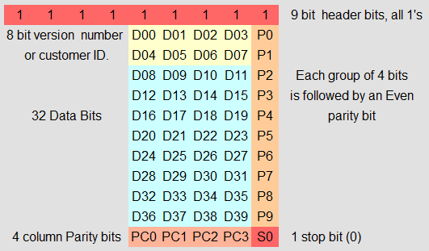
Figure 1Data format of EM4100
(1) First of all, the first line is 9 "1", which is the fixed format of EM4100.
D00 to D03 after
(2) is the first ID. P0 indicates the parity of the first line (for example, 0000_0/0001_1/0110_0). If the parity is not even, the parity is set to 1. P0-p9 are the parity of the first four bits of each row.
(3) PC0~PC3 are the parity checks of each column (P0-P9).
B). Manchester coding ^{[1]}
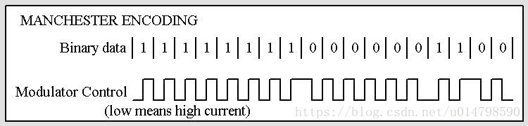
Figure 2 Manchester coding

2. Programming
a). RDM6300 introduction
RDM6300 is a 125KHz ID card reader module for reading EM4100 compatible ID card information. It is composed of a C8051F330 and a LM358D dual op-amp.
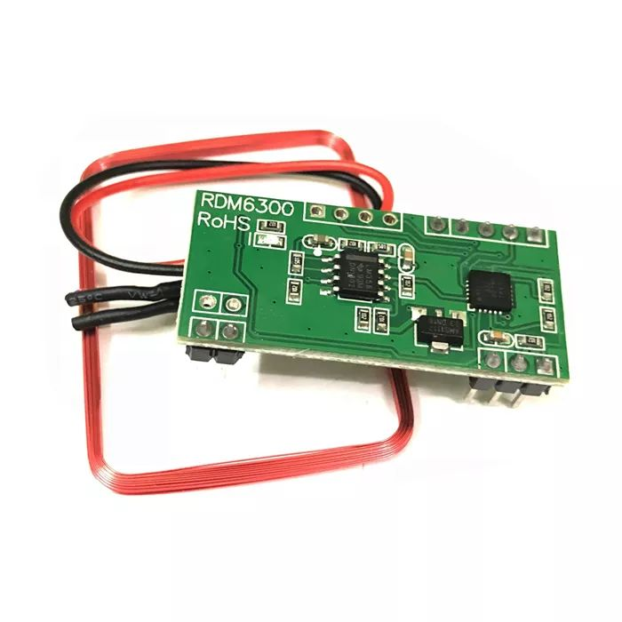
Figure 3 RDM6300

b). The following screenshot is a schematic of the RDM6300
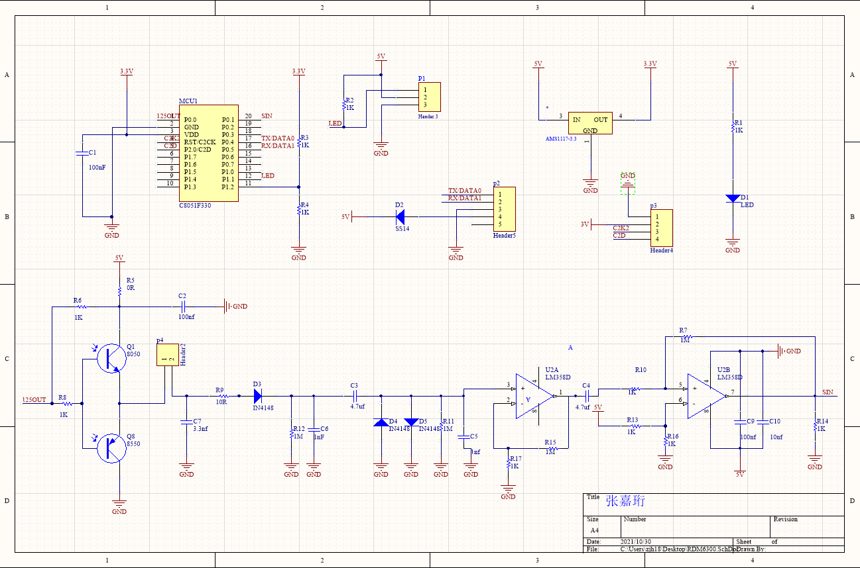
Figure 4 Schematic diagram

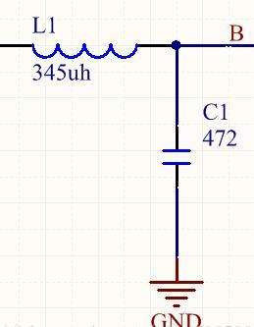
Figure 5 LC resonance circuit

c). Pin definition
The first set of 5 pins, square feet (outwards) is pin 1
Serial port baud rate 9600

PIN1 TX
PIN2 RX
PIN3
PIN4 GND
PIN5 +5V
The second set of 2 pins, in no order
PIN1 ANT1
PIN2 ANT2
The third set of 3 pins, square feet (out) is pin 1
PIN 1 is usually 5V, but it will be reduced to 0V for successful card reading

PIN1 LED
PIN2 +5V
PIN3 GND
The fourth group of 4 pins, away from the 5pin port, is pin 1
This is the C8051F330 firmware firing pin

PIN1 GND
PIN2 3.3 V
PIN3 C2CK
PIN4 C2D
d). Code
According to the corresponding pins, connect Arduino Uno, the code is as follows
1  2  3  4  5  6  7  8  9  10  11  12  13  14  15  16  17  18  19  20  21  22  23  24  25  26  27  28  29  30 | #include <SoftwareSerial.h>  #include <RDM6300.h>  SoftwareSerial RFID(6, 8); // RX and TX  int Led=13;  uint8_t Payload[6]; // used for read comparisons  RDM6300 RDM6300(Payload);  void setup()  {  pinMode(Led, OUTPUT);  RFID.begin(9600); // start serial to RFID reader  Serial.begin(9600); // start serial to PC  }  void loop()  {  while (RFID.available() > 0)  {  digitalWrite(Led, HIGH);  uint8_t c = RFID.read();  //Serial.print(c,HEX);  if (RDM6300.decode(c)) {  for (int i=0; i < 5; i++){  Serial.print(Payload[i], HEX);  Serial.print(" ");  }  Serial.println();  }  }  digitalWrite(Led, LOW);  delay(100);  }

e). Text
LC resonant circuit and sine wave measurement ^{[2]}
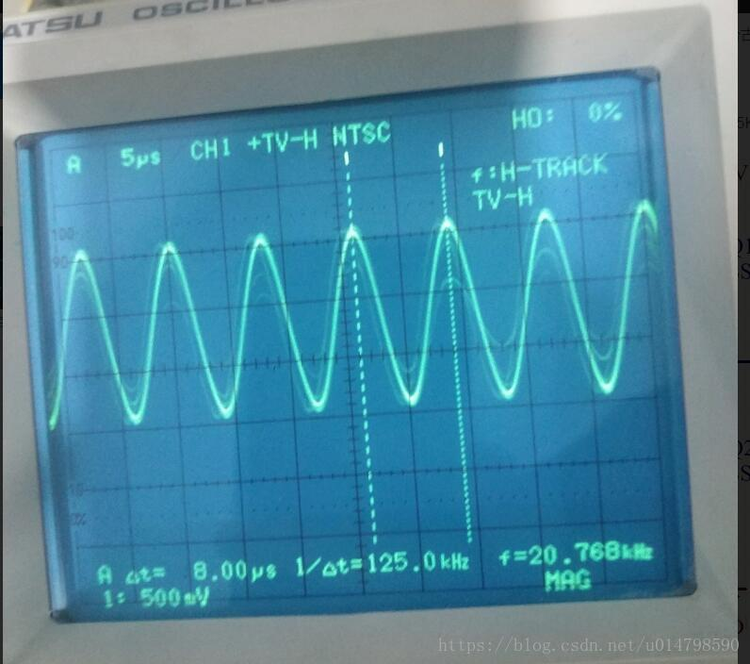
Figure 6 Text LC

6. Conclusion
RDM6300 was used to read the code through the Arduino development board, And through the teacher's tips in GITHUB to find a simple code to complete the project.
I benefited a lot from this project and understood the working principle of RDM6300.

7. reference
[1] IOsetting , (11条消息) 一、单片机读取ID卡（工作原理及电路）_u014798590的博客-CSDN博客
[2] N76E003, (11条消息) 一、单片机读取ID卡（工作原理及电路）_u014798590的博客-CSDN博客

评语及评分：

